

**Dermal Fillers Market to grow with a CAGR of 5.6% by 2027**

The global dermal fillers market is traversing a path from the growth phase to maturity as companies are focussing on developing variants of products currently available in the global [dermal fillers market](https://www.futuremarketinsights.com/reports/dermal-fillers-market). According to this new report titled “**Dermal Fillers Market: Global Industry Analysis (2012–2016) and Opportunity Assessment (2017–2027)”**that tracks the performance of the global dermal fillers market for a period of 10 years, the United States is a highly mature market with wide scale adoption of dermal fillers. This new report published by Future Market Insights discusses the high pricing competition and discounting practices between companies as well as physician practices that inflate margins and tend to hamper global adoption of the dermal filler procedure by patients.

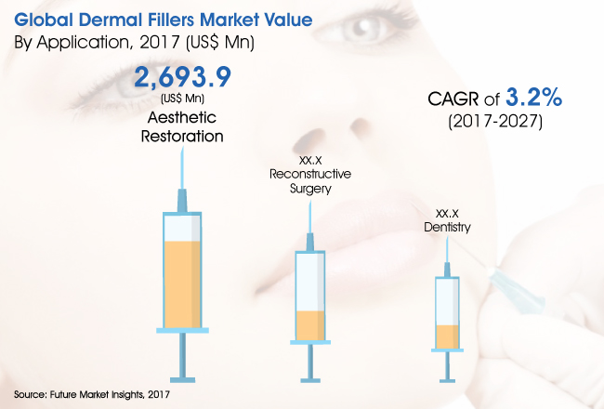

**Global Dermal Fillers Market: Trends**

Increasing preference for non-surgical procedures

Celebrity endorsements and direct consumer marketing

Increasing popularity of anti-ageing treatments and active interest for dermal rejuvenation

Advanced process technology for newer formulation of fillers and several combination products in the pipeline

Rising expenditure on cosmetics and aesthetics procedures

Increasing training programs for aesthetic practitioners and increasing foreign investments

Use of three dimensional imaging techniques for assessment and emergence of online sales channels

Beauty service demand patterns and micro-injectable dermal fillers that results in better looking skin

**For More Information about Report:**[**https://www.futuremarketinsights.com/reports/sample/rep-gb-5699**](https://www.futuremarketinsights.com/reports/sample/rep-gb-5699)

**Global Dermal Fillers Market: Forecast by Product Type**

On the basis of product type, the global dermal fillers market is segmented into absorbable and non-absorbable. The non-absorbable product type segment – with a market attractiveness index of 0.01 – is not expected to make a major impact over the forecast period. For example PMMA-based fillers are not as preferred, given their limited bio-compatibility.

**Global Dermal Fillers Market: Forecast by Ingredients**

The ingredient segment comprises hyaluronic acid, poly-L-Lactic acid, calcium hydroxylapatite, polymethyl methacrylate and collagen. Several manufacturers are developing newer, long-lasting formulations of hyaluronic acid-based fillers that are expected to lead to rapid adoption over the projected period. Collagen is expected to remain the least attractive ingredient in the global market in revenue terms with an attractiveness index of 0.02 over the projected period.

**Global Dermal Fillers Market: Forecast by Application**

The application segment includes aesthetic restoration, dentistry and reconstructive surgery. In 2017, the aesthetic restoration segment is projected to be valued at US$ 2,693.9 Mn and is estimated to grow significantly to reach a market value of US$ 3,646.1 Mn in the year 2027. This segment is likely to grow at a CAGR of 3.1% during the study period.

**Global Dermal Fillers Market: Forecast by Distribution Channel**

On the basis of distribution channel, the global dermal fillers market is segmented into retail pharmacies and drug stores, clinics and hospital pharmacies, and online pharmacies. Online pharmacies are expected to be the fastest growing distribution channel segment for dermal fillers over the forecast period given the rapid adoption rate.

**Global Dermal Fillers Market: Forecast by Region**

North America, Latin America, Eastern Europe, Western Europe, APEJ, Japan and MEA are the seven regions included in this report. The dermal fillers market in North America is expected to be the most lucrative, with a market attractiveness index of 2.5. Major players in the dermal fillers market, including Allergan and Galderma, are focussing on improving the sale of hyaluronicacid-based fillers in North America. Companies are trying to exploit full market potential and get maximum returns on R&D till patents for their products are valid. The market in APEJ is expected to be the fastest growing among all regions.

**Request for TOC @** [**https://www.futuremarketinsights.com/askus/rep-gb-5699**](https://www.futuremarketinsights.com/askus/rep-gb-5699)

**Global Dermal Fillers Market: Key Players**

Some of the key players operating in the global market for dermal fillers are GaldermaPharmaS.A., Sinclair Pharma plc., Zimmer Biomet Holdings, Allergan plc., Anika Therapeutics Inc., Merz Pharma GmbH & Co. KGaA, SunevaMedical Inc., Teoxane Laboratories Inc., Prollenium Medical Technologies Inc., Adoderm GmbH, Laboratoires Vivacy SAS, Fidia Pharma USA Inc.

**ABOUT US:**

Future Market Insights is the premier provider of market intelligence and consulting services, serving clients in over 150 countries. FMI is headquartered in London, the global financial capital, and has delivery centers in the U.S. and India.

FMI’s research and consulting services help businesses around the globe navigate the challenges in a rapidly evolving marketplace with confidence and clarity. Our customized and syndicated market research reports deliver actionable insights that drive sustainable growth. We continuously track emerging trends and events in a broad range of end industries to ensure our clients prepare for the evolving needs of their consumers.

**CONTACT:**

Future Market Insights

U.S. Office

616 Corporate Way, Suite 2-9018,

Valley Cottage, NY 10989,

United States

T: +1-347-918-3531

F: +1-845-579-5705

Email: [sales@futuremarketinsights.com](mailto:sales@futuremarketinsights.com)

Web:[https://www.futuremarketinsights.com](https://www.futuremarketinsights.com/)